**Classic Wood Panel Wallpaper in Blue**

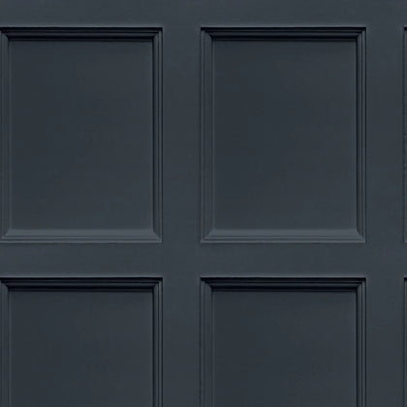Classic wood panel wallpaper in blue combines timeless elegance with a modern twist, making it a versatile choice for various interiors. The vertical wood panel design, painted in soft and muted blue tones, adds texture and depth to walls while creating a calm and sophisticated atmosphere. The subtle grain and shadow effects evoke the charm of traditional craftsmanship, blending seamlessly with both contemporary and classic decor. Ideal for living rooms, dining areas, or study spaces, this wallpaper transforms any room into a refined and inviting setting, perfect for those who appreciate understated beauty.